TRINITY INTERNATIONAL SS/COLLEGE
AFFILIATED TO TRIBHUWAN UNIVERSITY

LAB REPORT
OF
Statistics and Probability
In the partial fulfillment of the requirement for Bachelors in Computer Application (BCA), 3rd semester

SUBMITTED BY: SUBMITTED TO:
Shunishtha Tuladhar Suraj Poudel
Student ID: 30770 Submission Date:
Email: sunishthatuladhar22@gmail.com 19th baishakh, 2082

Certificate of Report Completion
This is to certify that the lab report for Statistics and Probability (CSCS 202 )is an academic report completely accomplished by Shunishtha Tuladhar with roll number 31 submitted in partial fulfillment for requirements of degree of Bachelor in Computer Application(BCA) under my guidance and supervision to the best of my knowledge and the work performed here is manifestation of his/her own creation.

Signature
Suraj Poudel
Date: 2nd May , 2025

Table of Contents
LAB |  | CONTENT | SIGNATURE
LAB 1 |  | Descriptive Statistics (Individual Series)
LAB 2 |  | Descriptive Statistics (Discrete Series)
LAB 3 |  | Combined Statistics for Two Groups
LAB 4 |  | Correlation Analysis
LAB 5 |  | Binomial Distribution
LAB 6 |  | Binomial Distribution
LAB 7 |  | Binomial Distribution
LAB 8 |  | Binomial Distribution
LAB 9 |  | Poisson Distribution
LAB 10 |  | Normal Distribution
LAB 11 |  | One-Way ANOVA
LAB 12 | Two-Way ANOVA

Submission Date: 19th baishakh, 2082

LAB 1:
OBJECTIVES: TO FIND MEAN, MODE, FIRST QUARTILE, THIRD QUARTILE, 75 PERCENTILE, RANGE, INTER QUARTILE RANGE, QUARTILE DEVIATION, COEFFICIENT OF QUARTILE DEVIATION, STANDARD DEVIATION, VARIANCE, COEFFICIENT OF VARIANCE IN INDIVIDUAL SERIES.
x
134
120
110
90
80
135
115
125
130
100
140

WORKING EXPRESSION:
EXCEL FORMULAS:
Mean (x̄)
=AVERAGE(range)
Mode
=MODE.SNGL(range) → Returns a single mode (for unimodal data)
=MODE.MULT(range) → Returns multiple modes (if dataset is multimodal)
First Quartile(Q1, 25th percentile)
=QUARTILE.INC(range, 1)
=PERCENTILE.INC(range, 0.25)
Second Quartile(Q2, Median, 50th percentile)
=MEDIAN(range)
=QUARTILE.INC(range, 2)
=PERCENTILE.INC(range, 0.5)
Third Quartile(Q3, 75th percentile)
=QUARTILE.INC(range, 3)
=PERCENTILE.INC(range, 0.75)
Range
=MAX(range) - MIN(range)
Interquartile Range
=QUARTILE.INC(range, 3) - QUARTILE.INC(range, 1)
Quartile Deviation
=(QUARTILE.INC(range, 3) - QUARTILE.INC(range, 1)) / 2
Coefficient of quartile deviation
=(Q3 - Q1) / (Q3 + Q1)
Standard Deviation
=STDEV.S(range)
Variance
=VAR.S(range)
Coefficient of variance
=(STDEV.S(range) / AVERAGE(range)) * 100 → For sample data
=(STDEV.P(range) / AVERAGE(range)) * 100 → For population data

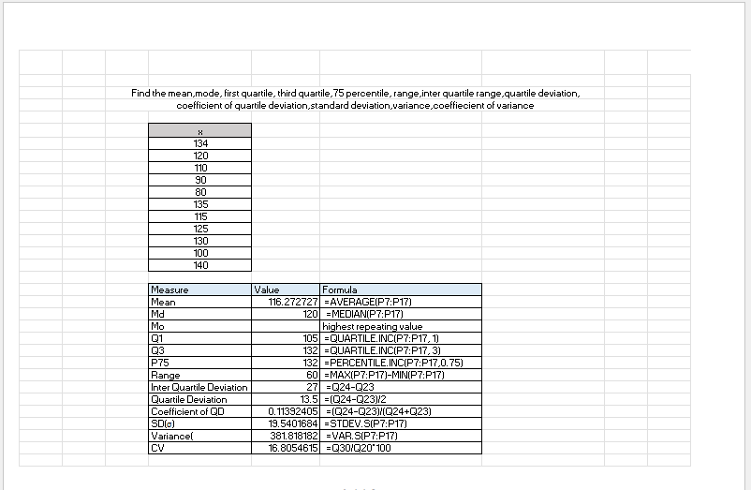
CALCULATION:

CONCLUSION:
The value of Mean= 116.27, Median= 120, Q1=105, Q3=132, P75=132, Range=60, Inter Quartile Deviation=27, Quartile Deviation=13.5, Coefficient of Quartile Deviation= 0.1139, Standard Deviation=19.54, Variance= 381.81, Coefficient of Variation= 16.805.

LAB 2:
OBJECTIVES: TO FIND MEAN, MODE, FIRST QUARTILE, THIRD QUARTILE, 75 PERCENTILE, RANGE, INTER QUARTILE RANGE, QUARTILE DEVIATION, COEFFICIENT OF QUARTILE DEVIATION, STANDARD DEVIATION, VARIANCE, COEFFICIENT OF VARIANCE IN DISCRETE SERIES.
Marks | No of students
20-40 | 15
40-60 | 9
60-80 | 18
80-100 | 12
100-120 | 20
120-140 | 13
140-160 | 11

WORKING EXPRESSION
EXCEL FORMULAS:
Mean (x̄)
=SUMPRODUCT(values_range, freq_range) / SUM(freq_range)
Mode
=INDEX(values_range, MATCH(MAX(freq_range), freq_range, 0))
First Quartile(Q1, 25th percentile)
=QUARTILE.INC(expanded data, 1)
=PERCENTILE.INC(expanded_data, 0.25)
Second Quartile(Q2, Median, 50th percentile)
=MEDIAN(expanded data)
=PERCENTILE.INC(expanded_data, 0.5)
Third Quartile(Q3, 75th percentile)
=QUARTILE.INC(expanded data, 3)
=PERCENTILE.INC(expanded_data, 0.75)
Range
=MAX(values_range) - MIN(values_range)
Interquartile Range
=Q3-Q1
Quartile Deviation
=(Q3-Q1)/2
Coefficient of quartile deviation
=(Q3 - Q1) / (Q3 + Q1)
Standard Deviation
=SQRT(SUMPRODUCT((values_range - mean)^2, freq_range) / (SUM(freq_range) - 1))
Variance
=SUMPRODUCT((values_range - mean)^2, freq_range) / (SUM(freq_range) - 1)
Coefficient of variance
=(Standard_Deviation / Mean) * 100

CALCULATION
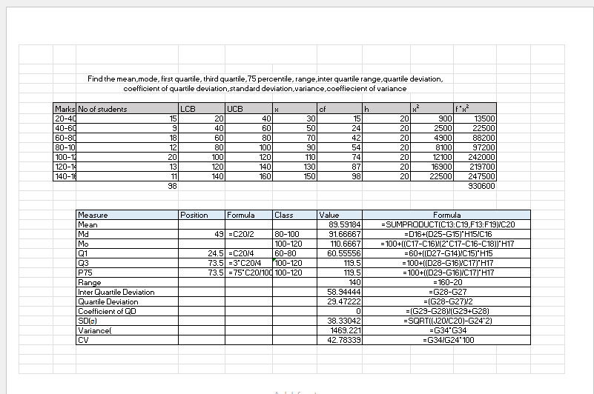

CONCLUSION:
The value of Mean=89.591, Median =91.667, Mode=110.667, Q1= 60.556, Q3= 119.5, P75= 119.5, Range=140, Inter Quartile Deviation= 58.944, Quartile Deviation= 29.472, Coefficient of QD= 0, Standard Deviation= 38.330, Variance= 1469.221, Coefficient of Variance= 42.78339.

LAB 3:
OBJECTIVES: TO FIND MEAN, SD, CV, COMBINED MEAN, COMBINED VARIANCE, COMBINED SD, COMBINED CV.
Model Campus(x) | Galaxy Campus(y)
25 | 29
31 | 28
29 | 35
24 | 34
26 | 30
23 | 28
27 | 29
28 | 30
29 | 34
26 | 27

WORKING EXPRESSION
Mean(x̄)
=AVERAGE(range)
=SUMPRODUCT(values, frequencies)/SUM(frequencies)
Standard Deviation
=STDEV.S(range) (Raw)
=SQRT(SUMPRODUCT((values - mean)^2, frequencies)/(SUM(frequencies) - 1)) (Discrete)
Coefficient of Variance
=(STDEV.S(range)/AVERAGE(range))*100 (Raw)
=(Sample_SD/Mean)*100 (Discrete)
Assume:
- Group 1: Mean in A1, SD in B1, Size in C1
- Group 2: Mean in A2, SD in B2, Size in C2
Combined Mean
=(C1*A1 + C2*A2)/(C1 + C2)
Combined Variance
=(C1*(B1^2 + (A1 - Combined_Mean)^2) + C2*(B2^2 + (A2 - Combined_Mean)^2))/(C1 + C2)
Combined Standard Deviation
=SQRT(Combined_Variance)
Combined Coefficient of Variance
=(Combined_SD/Combined_Mean)*100
CALCULATION
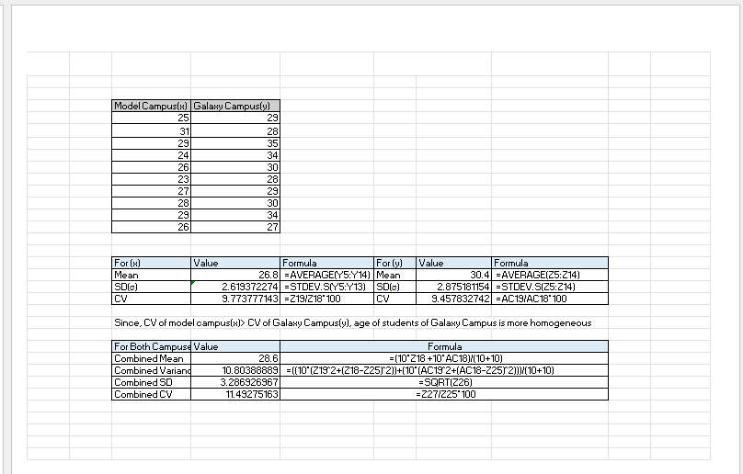
CONCLUSION:
The value of Mean of X= 26.8 and of Y= 30.4, SD of X= 2.6193 and of Y= 2.8751, CV of X= 9.773 and of Y= 9.4578
The value of Combined Mean= 28.6, Combined Variance= 10.80, Combined SD= 3.2869, Combined CV= 11.4927

LAB4:
OBJECTIVES: TO FIND CORRELATION COFFIECIENT AND PROBABLE ERROR
Age | BP
56 | 147
42 | 125
36 | 118
47 | 128
49 | 145
42 | 140
60 | 155
72 | 160
63 | 149
55 | 150

WORKING EXPRESSION:
EXCEL FORMULAS:
Karl Pearson’s Correlation Coeffiecient
=CORREL(array1, array2)
Correlation for Discrete Series
Mean_X = SUMPRODUCT(X_values, Frequencies)/SUM(Frequencies)
Mean_Y = SUMPRODUCT(Y_values, Frequencies)/SUM(Frequencies)
Cov_XY = SUMPRODUCT((X_values - Mean_X)*(Y_values - Mean_Y), Frequencies)/SUM(Frequencies)
σ_X = SQRT(SUMPRODUCT((X_values - Mean_X)^2, Frequencies)/SUM(Frequencies))
σ_Y = SQRT(SUMPRODUCT((Y_values - Mean_Y)^2, Frequencies)/SUM(Frequencies))
r = Cov_XY / (σ_X * σ_Y)

CALCULATION
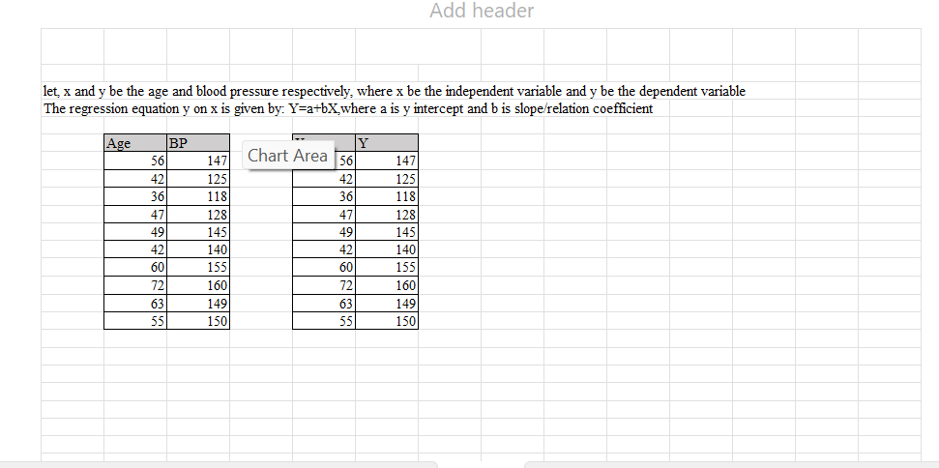
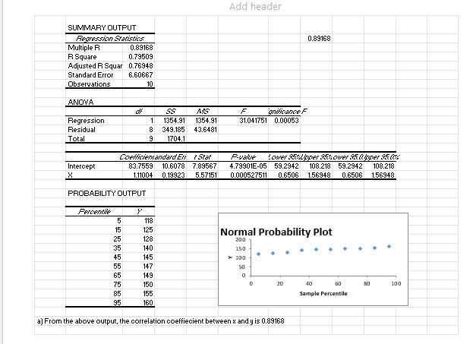

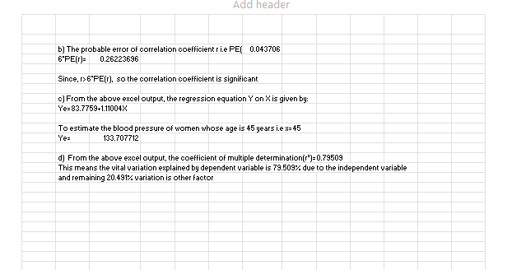

LAB 5:
OBJECTIVES: TO FIND BINOMIAL DISTRIBUTION
a) X=4
b) X≤3
c) X<2
d) X>1
e) X≤4
f) X≥1
g)2≤X<4
h)1≤X≤4
i) X=0
WORKING EXPRESSION:
EXCEL FORMULA:
Binomial Distribution:
=BINOM.DIST(k, n, p, FALSE)
Where,
- k: Number of successes
- n: Number of trials
- p: Probability of success per trial
- FALSE: Returns the probability mass function (PMF)
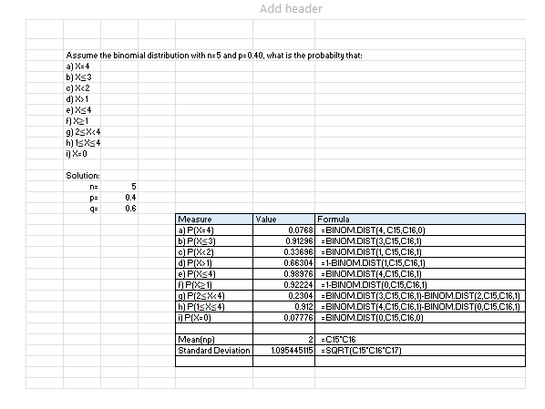
CALCULATION:

CONCLUSION:
Measure | Value
a) P(X=4) | 0.0768
b) P(X≤3) | 0.91296
c) P(X<2) | 0.33696
d) P(X>1) | 0.66304
e) P(X≤4) | 0.98976
f) P(X≥1) | 0.92224
g) P(2≤X<4) | 0.2304
h) P(1≤X≤4) | 0.912
i) P(X=0) | 0.07776

LAB 6:
OBJECTIVES: TO FIND BINOMIAL DISTRIBUTION
- Exactly four will be rejected? P(X=4)
b) Exactly eight? P(X=8)
c) Fewer than three? P(X<3)
d) More than Five? P(X>5)

WORKING EXPRESSION:
EXCEL FORMULA:
Binomial Distribution:
=BINOM.DIST(k, n, p, FALSE)
Where,
- k: Number of successes
- n: Number of trials
- p: Probability of success per trial
- FALSE: Returns the probability mass function (PMF)

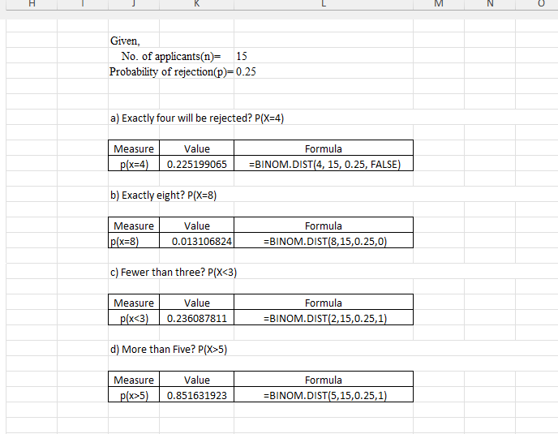
CALCULATION

CONCLUSION
a)Exactly four will be rejected? P(X=4) : 0.225199065
b) Exactly eight? P(X=8): 0.013106824
c) Fewer than three? P(X<3): 0.236087811
d) More than Five? P(X>5): 0.851631923

LAB 7:
OBJECTIVES: TO FIND BINOMIAL DISTRIBUTION
a) at least two will have thick enough coating P(X≥2)
b) at most one will have thick enough coating P(X≤1)
c) exactly 5 will have thick enough coating P(X=5)

WORKING EXPRESSION:
EXCEL FORMULA:
Binomial Distribution:
=BINOM.DIST(k, n, p, FALSE)
Where,
- k: Number of successes
- n: Number of trials
- p: Probability of success per trial
- FALSE: Returns the probability mass function (PMF)

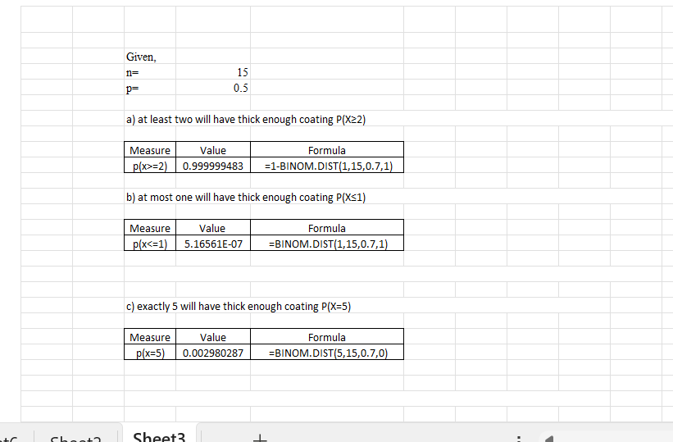
CALCULATION
CONCLUSION
a) at least two will have thick enough coating P(X≥2)= 0.999999483

b) at most one will have thick enough coating P(X≤1)= 5.16561E-07

c) exactly 5 will have thick enough coating P(X=5)= 0.002980287

LAB 8:
OBJECTIVE: TO FIND BINOMIAL DISTRIBUTION
x | f
0 | 28
1 | 62
2 | 46
3 | 10
4 | 4

WORKING EXPRESSION:
EXCEL FORMULAS:
Binomial Distribution:
=BINOM.DIST(k, n, p, FALSE)
Where,
- k: Number of successes
- n: Number of trials
- p: Probability of success per trial
- FALSE: Returns the probability mass function (PMF)
CALCULATION
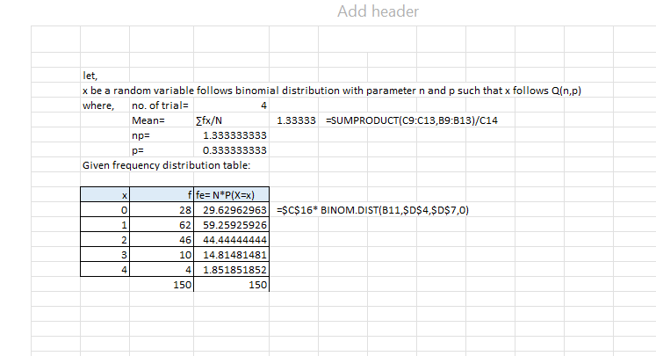

LAB 9:
OBJECTIVE: TO FIND POISSON DISTRIBUTION
- Exactly one
- At most three
- More than two
- At least one
- Less than three
WORKING EXPRESSION
EXCEL FORMULAS:
POISSON DISTRIBUTION
=POISSON.DIST(x, mean, cumulative)
Where,
- x: Number of events
- mean: Expected number of events (λ, lambda)
- cumulative:
  - TRUE = returns cumulative probability (P(X ≤ x))
  - FALSE = returns probability mass function (P(X = x))
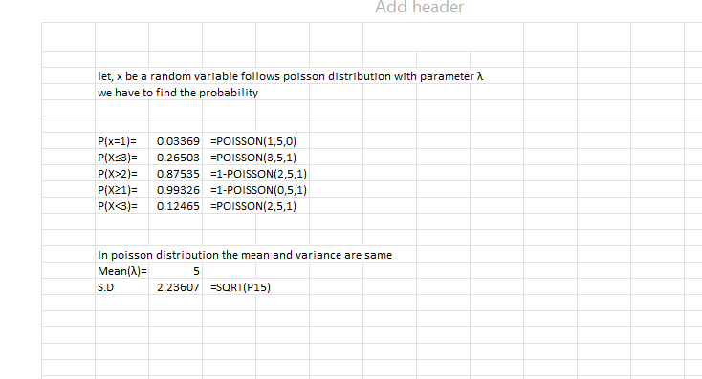
CALCULATION
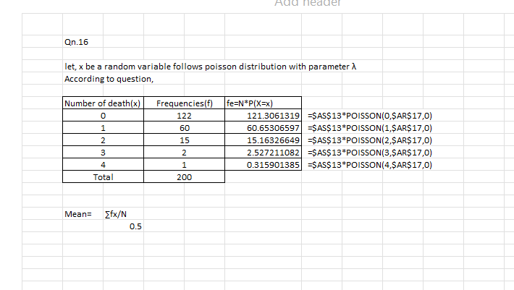
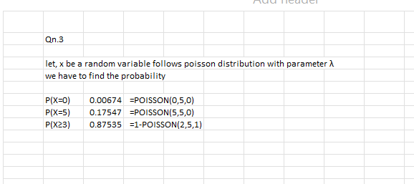

CONCLUSION
Excel’s POISSON.DIST function makes it easy to calculate both exact and cumulative probabilities, helping with decision-making in fields like operations, finance, and risk management.
We use POISSON.DIST(x, mean, FALSE) for exact probabilities (P(X = x)) and POISSON.DIST(x, mean, TRUE) for cumulative probabilities (P(X ≤ x)). The Poisson distribution is ideal for low-probability, independent events (e.g., customer arrivals, system failures, call center volumes).

LAB 10:
OBJECTIVE: TO FIND NORMAL DISTRIBUTION
- More than 75
- More than 112
- Less than 70
- Greater than 75 less than 85
- Less than 80 or more than 110
- Less than value of 70%
WORKING EXPRESSION
EXCEL FORMULAS
NORMAL DISTRIBUTION
=NORM.DIST(x, mean, standard_dev, cumulative)
Where,
- x: The value for which you want the distribution.
- mean: The average (μ) of the distribution.
- standard_dev: The standard deviation (σ).
- cumulative:
  - TRUE = Cumulative probability (P(X ≤ x))
  - FALSE = Probability density (height of the curve at x)
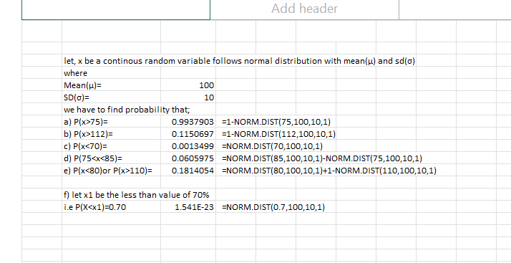
CALCULATION

CONCLUSION:
More than 75= 0.993790335
More than 112= 0.1150696
Less than 70= 0.001349898
Greater than 75 less than 85= 0.060597536
Less than 80 or more than 110= 0.181405386
Less than value of 70%= 1.54128E-23

LAB 11:
OBJECTIVES: SINGLE FACTOR ANOVA/ ONE-WAY ANOVA
Computer 1 | Computer 2 | Computer 3
83 | 56 | 79
83 | 76 | 95
76 | 72 | 87

WORKING EXPRESSION
EXCEL FORMULA:
One-Way ANOVA (Single Factor)
Tests differences between groups when there's only one independent variable.
Using Data Analysis Toolpak
- Go to Data → Data Analysis → Anova: Single Factor
- Input:
  - Input Range: Select your data (include headers if any)
  - Grouped By: Columns or Rows
  - Alpha (α): Typically 0.05 for 95% confidence
  - Output Range: Select where to display results

CALCULATION
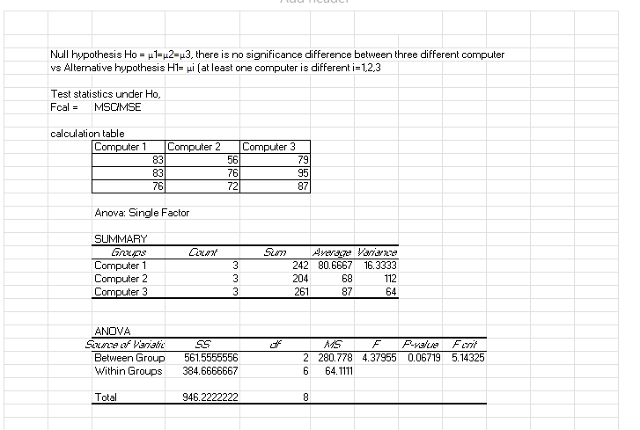
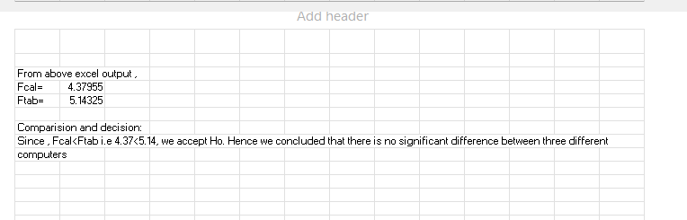
CONCLUSION
Since , Fcal<Ftab i.e 4.37<5.14, we accept Ho. Hence we concluded that there is no significant difference between three different computers.

LAB 12:
OBJECTIVE: TWO-WAY ANOVA
Channel length | width
 | 1 | 2 | 3 | 4 | 5
1 | 0.7 | 0.8 | 0.8 | 0.9 | 1
2 | 0.8 | 0.8 | 0.9 | 0.9 | 1
3 | 0.9 | 1 | 1.7 | 2 | 1
4 | 1 | 1.5 | 2 | 3 | 20

WORKING EXPRESSION
EXCEL FORMULA:
Using Data Analysis Toolpak
- Enable Data Analysis Toolpak (if not already enabled):
  - File → Options → Add-ins → Analysis ToolPak → Go → Check Analysis ToolPak → OK
- Run Two-Way ANOVA:
  - Data → Data Analysis → Anova: Two-Factor With Replication
  - Input Range: Select your data (include headers)
  - Rows per sample: Number of observations per group (e.g., if each group has 5 samples, enter 5)
  - Alpha (α): Typically 0.05 (5% significance level)
  - Output Range: Select where to display results

CALCULATION
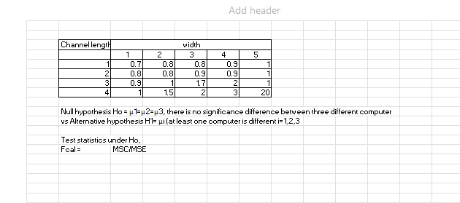
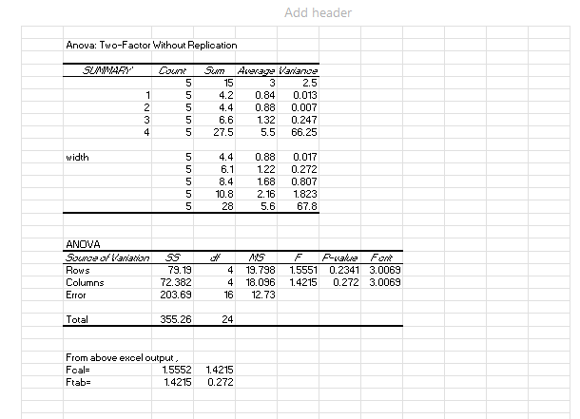
CONCLUSION
nce , Fcal>Ftab we accept Ho. Hence we concluded that there is significant difference between three different computers.

